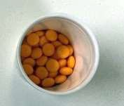DULCOLAX (ORIGINAL)

DULCOLAX FALSIFICATION

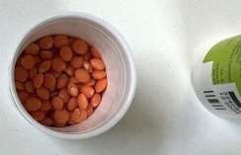

Page 2 / 2